**MISSION:**

Wisdom Pet Medicine strives to blend the best in traditional and alternative medicine in the diagnosis and treatment of companion animals including dogs, cats, birds, reptiles, rodents, and fish. We apply the wisdom garnered in the centuries old tradition of veterinary medicine, to find the safest and most effective treatments and cures, while always maintaining a caring relationship with our patients and their guardians.

Your pet will get the most out of his or her visit to Wisdom, if you’re able to describe your observations of him or her over the last several days prior to your visit. This includes paying close attention to your pet’s eating habits, bowl-movement frequency, mood, activity level, sleeping habits, or any unusual behaviors such as limping or excessive scratching. Even the slightest change in a pet’s behavior can indicate the start of a health problem. As your pet’s guardian, you have the greatest insight into these behaviors or symptoms, and can call them to the attention of your veterinarian before serious problems occur. By simply being observant, you can make a great difference in the quality of your pet’s healthcare.

# VACCINATIONS:

Dogs and cats are susceptible to a variety of illnesses that can be completely prevented by following the appropriate vaccination schedule. At Wisdom, we approach vaccinations on a patient by patient basis, depending on the health and age of a dog, while also taking into account the vaccination schedules published by leading veterinary medical schools. Talk to your veterinarian about vaccinations for the most common preventable illnesses in your dog or cat. For dogs, this includes core vaccines for rabies, distemper, parvovirus, and adenovirus, as well, as non-core vaccines including Bordetella, parainfluenza, Lyme disease, leptospirosis, and canine influenza. For cats, this includes core vaccines for rabies, feline distemper, feline herpesvirus, calicivirus, and non-core vaccines including feline leukemia and Bordetella.

# CHECKUPS:

Regular checkups are a key factor in pet wellness, and can often unearth problems that could lead to health issues down the road. The American Animal Hospital Association recommends annual checkups for cats and dogs, and checkups every six months for senior cats and dogs. Annual checkups are also recommended for birds, rabbits, ferrets, reptiles, rodents, and other exotic pets. During the checkup, one our experienced Wisdom vet techs, will obtain a health history and ask about any recent problems or observations you've made regarding your pet's health. The vet tech will also measure your pet's weight, temperature, pulse, and respiration rate. A Wisdom veterinarian will then follow up with a complete "head to tail" examination, checking the entire body for any signs of parasites, lumps, hair loss, redness, infection, and other symptoms or maladies. At the end of your pet's exam, we'll take a blood sample to test for a wide range of conditions and deficiencies. The cost of a pet's wellness exam each year is well worth the investment - and can often lead to savings down the road, when an illness is caught early and thwarted.

## SENIOR PETS:

Senior pets generally require more medical attention than their younger counterparts, just as senior humans do. So when is a pet considered "senior"? Your Wisdom veterinarian can answer that, but in general, small dogs live longer than large breeds, and cats live longer than dogs. A small dog might be senior at the age of ten, whereas a giant breed, such as a Great Dane, would likely be considered senior at the age of six or seven. It's important that your pet receive a full senior wellness exam every six months that includes a urinalysis, comprehensive blood screening, and a fecal test. Seniors are prone to weight and mobility changes, osteoarthritis, kidney, heart, and liver disease, tumors and cancers, and hormone disorders, such as diabetes and thyroid imbalance - and senior testing can help slow down the progression of, or even prevent, certain conditions. Our pets are living longer and healthier lives, thanks, in part, to modern veterinary medicine, and also because pet guardians are more aware and educated about how to care for their pets, especially those in their senior years.

## DENTAL CARE VIDEO:

You know the importance of dental hygiene for humans, but did you know that dogs and cats also need regular attention to their pearly whites? Poor dental hygiene in pets can lead to periodontal disease, a bacterial infection which causes bad breath, drooling, tooth decay, and tooth loss. When the infection is left unchecked, it can eventually enter the bloodstream causing significant damage to the liver, heart, and kidneys. In fact, poor dental hygiene is a leading cause of serious health problems in companion animals. Roughly 70 to 80 percent of dogs and cats have periodontal disease by the time they're three years old, yet it's one of the most preventable and/or treatable health problems. By brushing your pet's teeth at least once a week, and ideally every other day, you can stop periodontal disease in its tracks, or keep it from ever starting. Make sure to use a pet-size toothbrush and a pet-approved toothpaste only, as human toothpaste can make your pet sick. Watch this video to see one of our Wisdom patients, Pav, have his teeth cleaned by his own guardian, Shannon. And, as always, if you have questions about your pet's dental or health care, please contact Wisdom Pet Medicine for advice.

[Video is being shot on Friday, October 7th]

## BREAK THE DEADLY HEARTWORM CYCLE

Heartworm is a serious illness where worms actually invade the heart of an otherwise healthy pet, after the pet has been inflicted with a bite from an infected mosquito. If you live in a location where mosquitoes are common, and/or your veterinarian has indicated that heartworm is a local threat, it’s important to get your pet on heartworm preventative medication. Your pet must have a blood test to ensure he or she tests negative for heartworm, before being given the medication, as the drug can be dangerous to an animal who is already infected. Heartworm is completely preventable, simply by administering the medication, as it interferes with the heartworm life cycle, killing the microfilariae before they develop into worms. Contact your veterinarian to see if heartworm prevention medication is right for your pet.

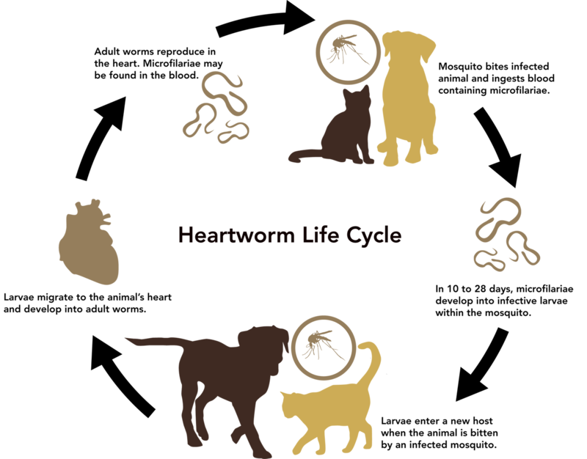

## PET VACCINATION SCHEDULE

Talk to your veterinarian about vaccinations for the most common preventable illnesses in your dog or cat. For dogs, this includes core vaccines for rabies, distemper, parvovirus, and adenovirus, as well, as non-core vaccines including Bordetella, parainfluenza, Lyme disease, leptospirosis, and canine influenza. For cats, this includes core vaccines for rabies, feline distemper, feline herpesvirus, calicivirus, and non-core vaccines including feline leukemia and Bordetella. Your veterinarian will discuss the [vaccination timeline](http://wisdompets.com/services/cat-vaccination-schedule/) with you.

## Our Products and Services

Dog Vaccination Package

Cat Vaccination Package

Rabies 1 or 3-year Vaccination

Parasite Treatment Package

Microchip Service

Basic Teeth Cleaning and Exam

Strong Joints Dog Supplement

Healthy Coat Dog Supplement

Probiotic Dog Treats

Small Hypoallergenic Pet Bowl

Large Hypoallergenic Pet Bowl

Cat Hairball Remedy Gel

Probiotic Cat Treats

Here Kitty Kitty Organic Catnip

Calm Cat Anxiety Relief Spray

Medicated Dog Shampoo

Strong Joints Cat Supplement

Healthy Coat Dog Supplement

Senior Dog Vitamin Chews

Kidney Support Liquid Dietary Supplement

Advance Pet Oral Care Toothbrush and Toothpaste

### IS YOUR PET DEPRESSED?

Has your pet seemed lethargic, bored, or had any sudden behavioral changes, despite getting a clean bill of health from your veterinarian? If so, this could signal depression. Cats, dogs, and other companion animals suffer depression for many of the same reasons that people can, such as moving to a new home or losing a human or animal companion. Fortunately, anti-depressant medications can help your pet feel and act more like his or her old self.

To understand how anti-depressants work, [watch this animation](http://wisdompets.com/educational-info/serotonin-flow) that shows a simplified version of how serotonin flows in a healthy, non-depressed brain. When depression results from lowered serotonin levels, Prozac, which belongs to a class of antidepressants known as serotonin reuptake inhibitor, can often help. These antidepressants increase the general availability of serotonin in the brain by slowing or stopping the proteins normally responsible for the collection of serotonin from synapses. This greater amount of free-floating serotonin increases the regularity with which serotonin receptors are activated.

If your pet is showing signs of depression, talk to your veterinarian right away to rule out illness or injury, and to assess if treatment or medication is needed.

# ABOUT US

Wisdom Pet Medicine was founded by Dr. Darren Winthrop, Dr. Elizabeth Chase, and Dr. Kimberly Sanders to bring the best in traditional and alternative medicine to the local community. The three doctors met while pursuing their veterinary education at Colorado State University, one of the nation's top-rated vet schools. After going their own ways (for almost a decade), to work for different veterinary clinics across the country, the doctors decided it was time to combine their diverse knowledge and skills under one practice at Wisdom Pet Medicine.

Our veterinary hospital provides general and specialty vet medicine, and serves as a major surgical center in the region. We're often referred difficult cases from other vet clinics throughout the region, state, and country, and even treat cases from other countries. With specialties in orthopedics, dermatology, oncology, radiology, and ultrasound, we're able to diagnose and treat more conditions in-house, allowing your pet to feel comfortable in friendly and familiar surroundings for the duration of his or her care. We all love animals and strive to make your pet's experience as positive as possible, and even have a pet play yard in the back of our clinic where we give our overnight visitors regular time away from the stress of confinement and treatment. We're proud to say that most of our patients come in wagging their tails happily on return visits - a true indicator that we've made them feel safe and secure. We're honored that you've entrusted your pet's care to us, and we'll stand by our commitment to provide the absolute best in veterinary medicine.

DR WINTHROP

Dr. Winthrop is the guardian of Missy, a three-year old Llaso mix, who he adopted at the shelter. Dr. Winthrop is passionate about spay and neuter and pet adoption, and works tireless hours outside the clinic, performing free spay and neuter surgeries for the shelter.

DR CHASE

Dr. Chase spends much of her free time helping the local bunny rescue organization find homes for bunnies, such as Kibbles - a Dalmatian bunny who is part of the large Chase household, including two dogs, three cats, and a turtle.

DR SANDERS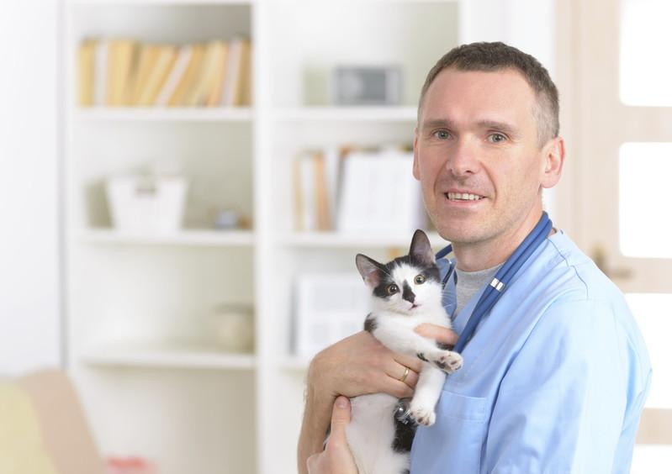

Leroy walked into Dr. Sanders front door when she was moving into a new house. After searching for weeks for Leroy's guardians, she decided to make Leroy a part of her pet family, and now has three cats.